Part 1: Exploring and Applying Ensemble Methods
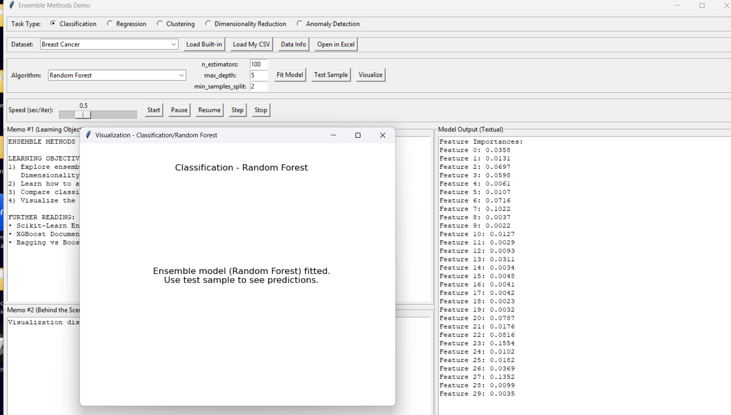
Figure explanation:
The alpha-phase GUI successfully loads the Breast Cancer dataset and fits a Random Forest classification model. The textual output panel shows feature importances, which is useful for interpretation. However, the visualization window does not present meaningful classification performance plots such as a confusion matrix, decision boundary, ROC curve, or accuracy summary. Instead, it only displays a static text message, which limits the usefulness of the visualization component.
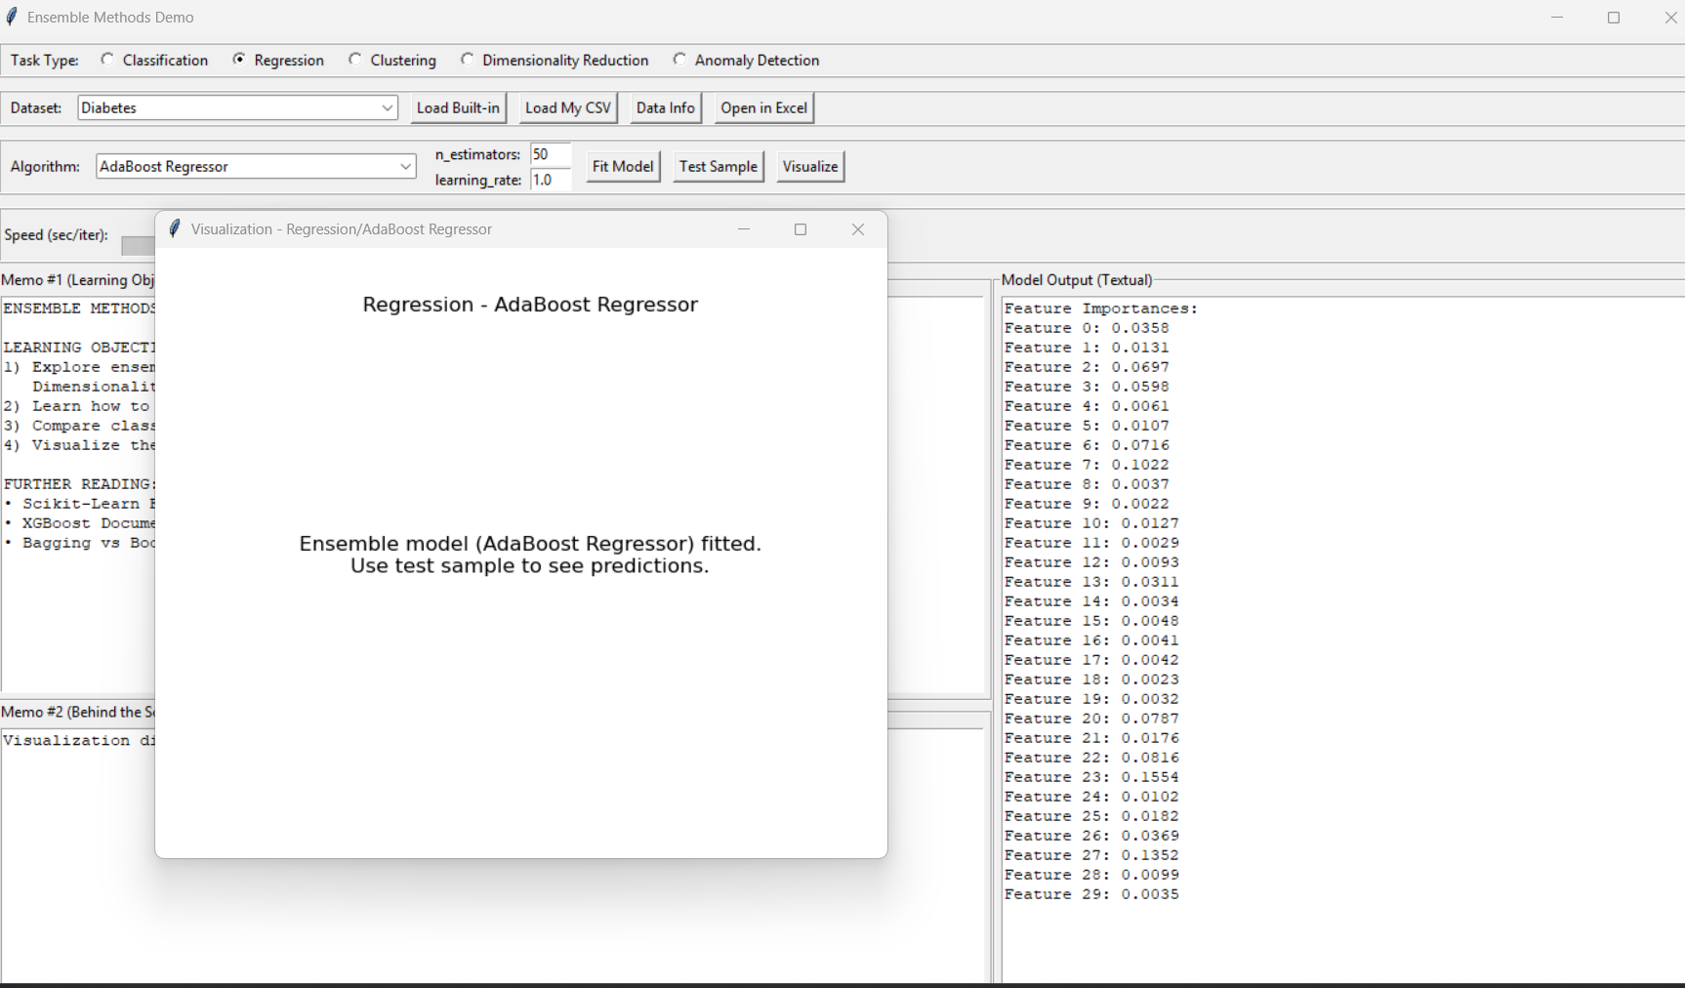
Figure Explanation (Regression)

The regression task was tested using the Diabetes dataset with the AdaBoost Regressor model. The system successfully fitted the model and displayed feature importances, indicating that the model training process works correctly. However, the visualization output is limited, as it only displays a static text message instead of meaningful regression plots such as predicted vs actual values, residual plots, or evaluation metrics like RMSE or R². This limits the usefulness of the visualization for understanding model performance.
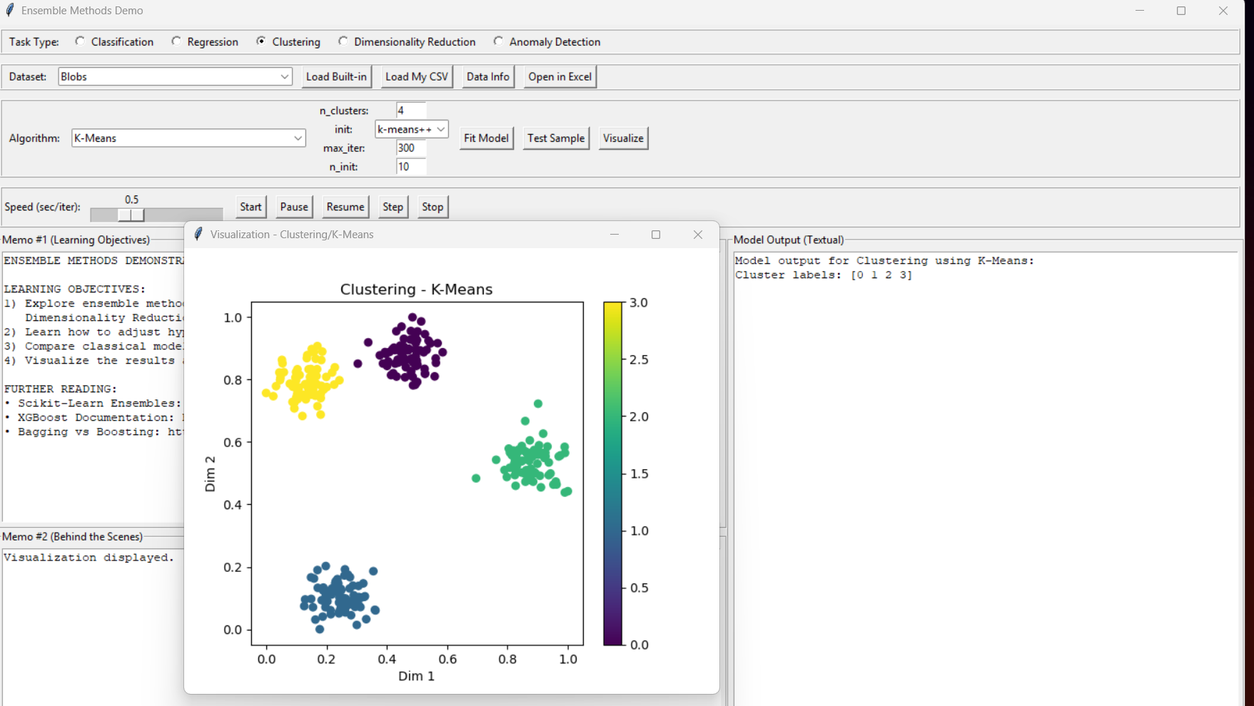
clustering:

The clustering task using K-Means on the Blobs dataset produced a meaningful visualization, displaying clusters in a two-dimensional space. Unlike classification and regression tasks, clustering visualization is more effective because it directly represents data grouping. This indicates that the visualization component works better for unsupervised learning tasks.
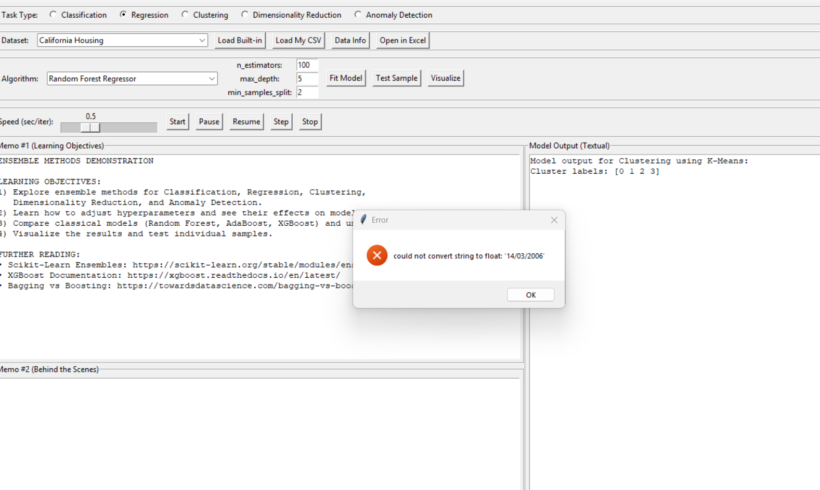
Figure explanation:
When the custom CSV file Aquifer_Petrignano.csv was loaded, the alpha-phase program produced an error stating that it could not convert the date value '14/03/2006' to float. This indicates that the CSV loading pipeline is not able to handle non-numeric columns such as date fields. The program attempts to scale the full dataset directly as numeric input, which causes failure for real-world datasets containing timestamps or categorical information. This highlights an important usability and preprocessing limitation in the current implementation.

Additional issue discovered during CSV testing
A further problem was identified when testing the custom aquifer dataset. The program crashed because it attempted to convert the Date column directly into a floating-point value. This shows that the CSV loading procedure does not include basic preprocessing steps for date or non-numeric variables. In practical machine learning workflows, date fields should either be transformed into engineered numeric features or excluded before scaling and fitting. The lack of such preprocessing makes the current CSV loading functionality unsuitable for many real datasets.

Part 2: Evaluating and Validating Your Model
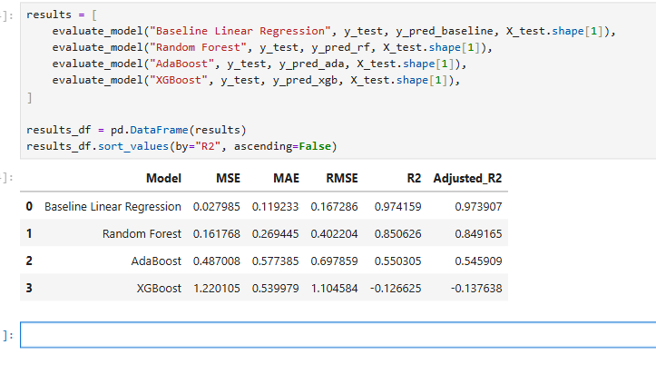
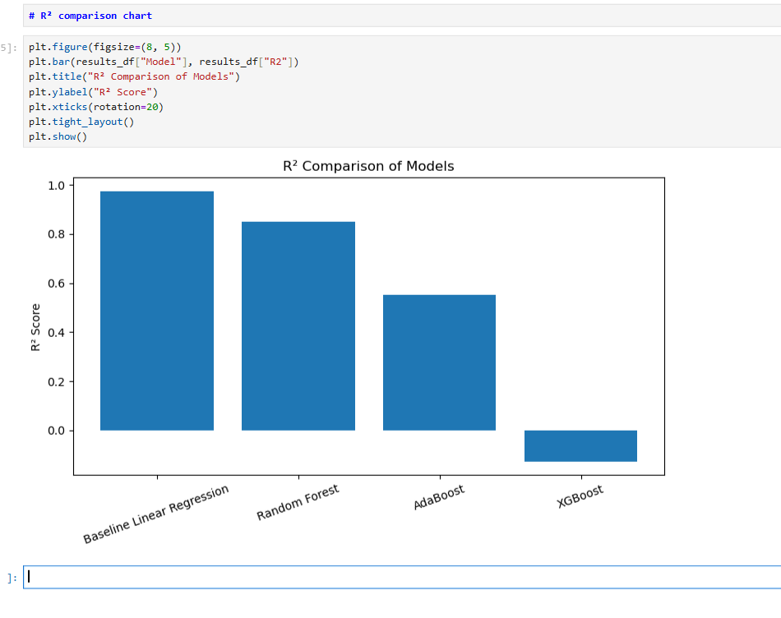

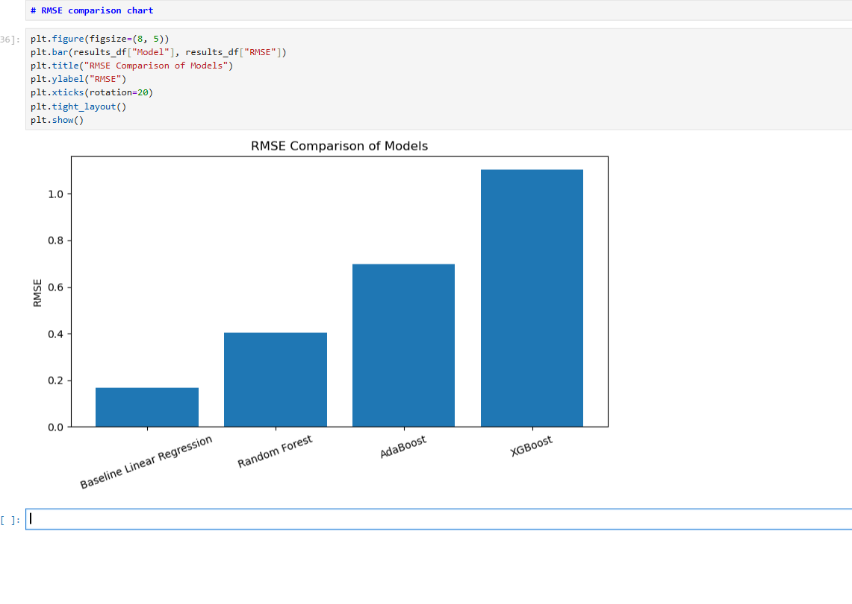

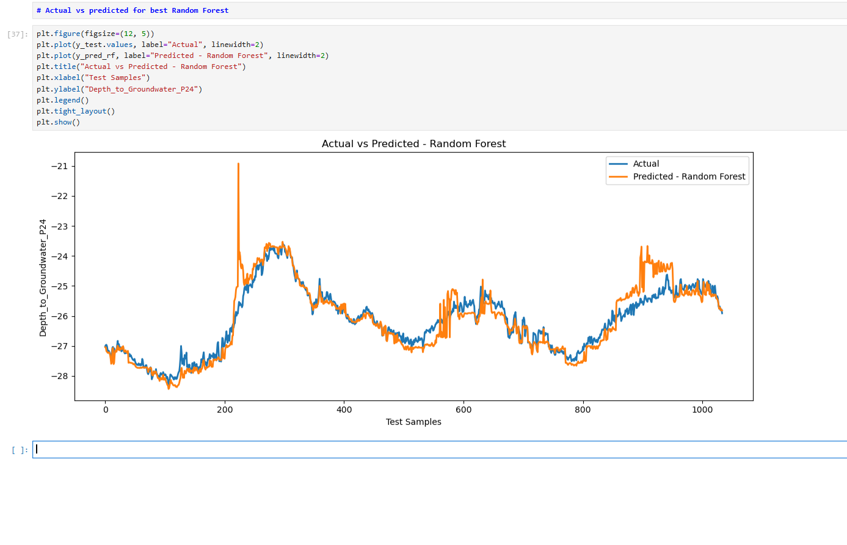

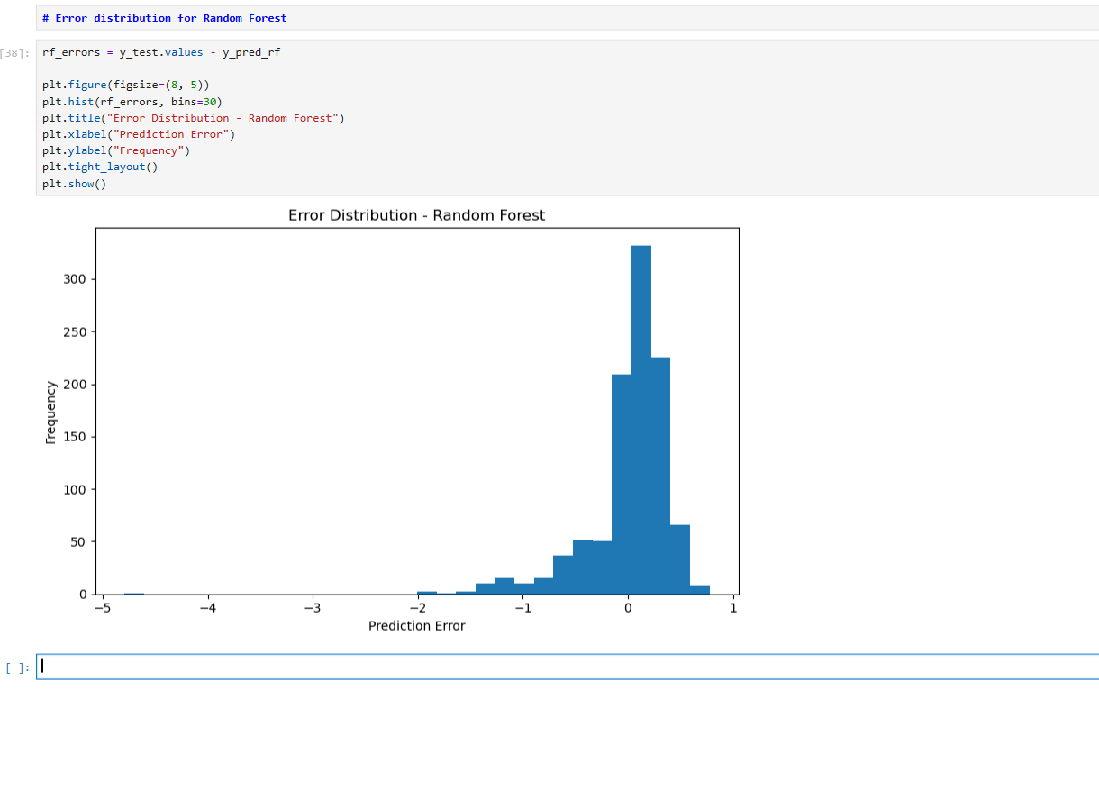

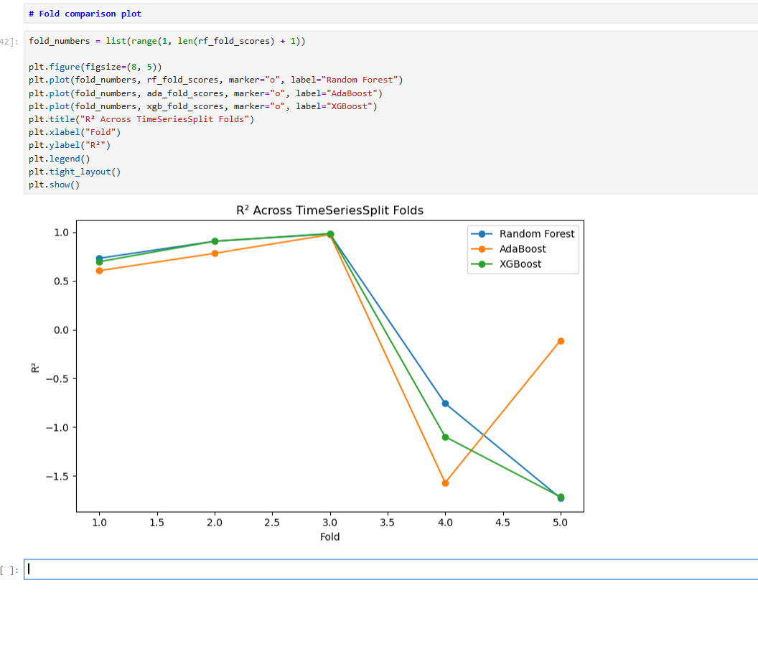

Part 3: Incorporating Advanced Scikit-Learn Techniques

